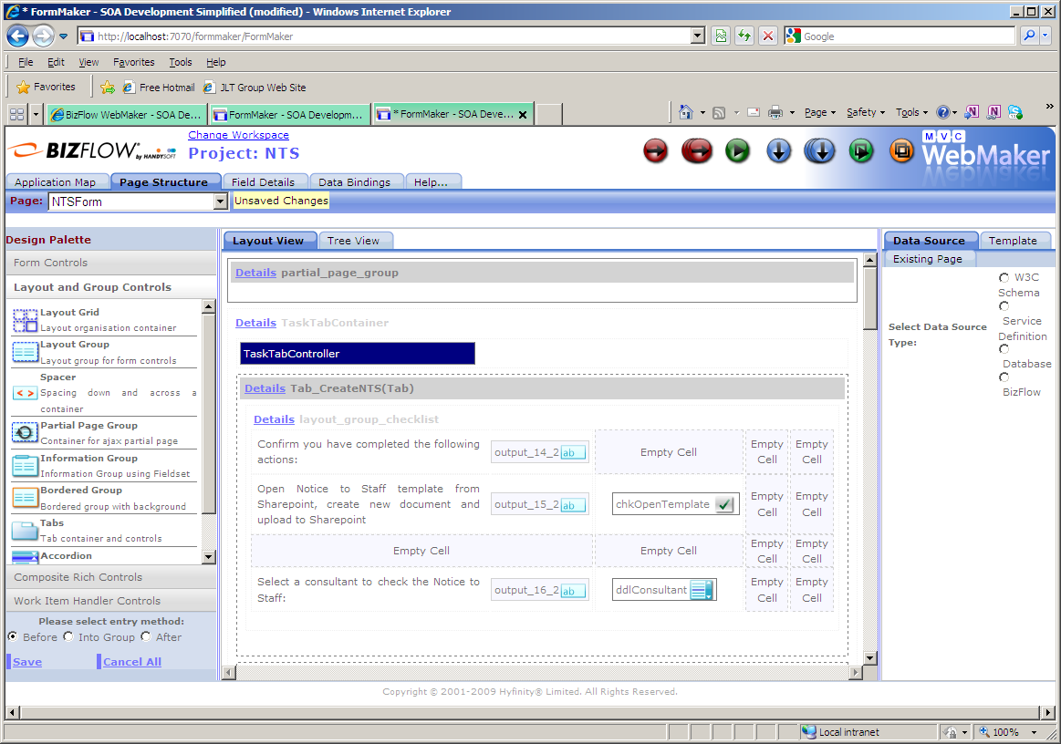
Add a partial_page_group to host the _Page_Header project

Create a page event to load the _Page_Header by making an Ajax call to the LoadPageHeader action.

Go to the Deployment options on the _Page_Header project and change the Morphyc File to point to the project to be header is to be included in.

Click Deploy project

Go back into the All Details tab and select Advanced Deployment.

Select view-Page Painter

Select “Web Application” and change the name of webapps in the Webserver Location to be the name of the project to host the header.

Click Deploy Node.

